SPCR GoodGrants guide

Login

By following this link: NIHR School for Primary Care Research (grantplatform.com) you will get to this login/register screen. From here enter your email address and click continue.
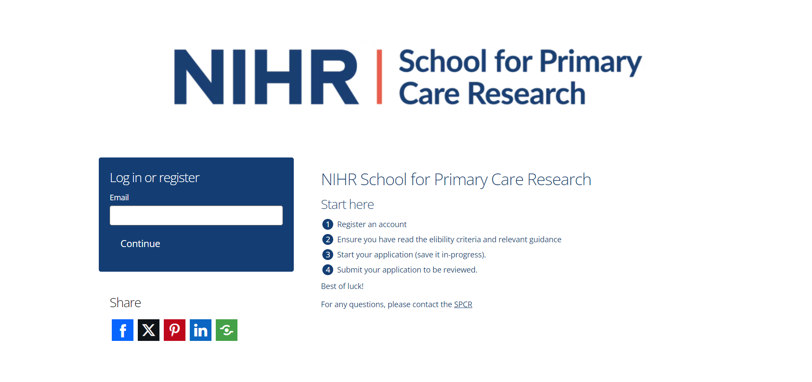
If it is the first time you’ve tried to login you will be taken to this screen to enter a security code sent to your email address.


If you have logged in before you will get an option to enter the password you previously set up
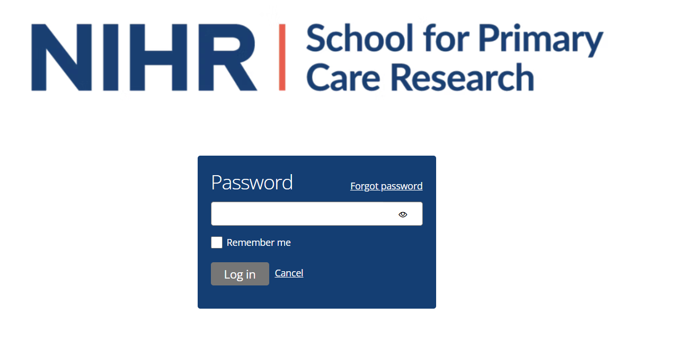

Starting an application

Once you have logged in you should come to this home page
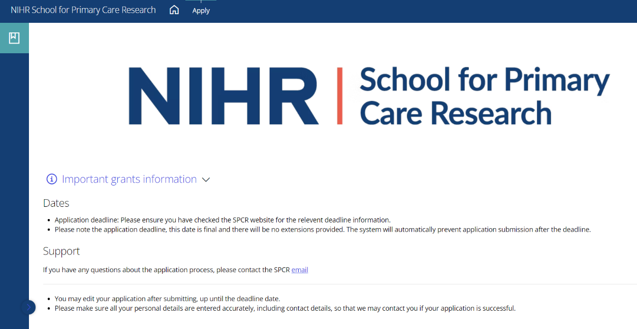
Use the apply button at the top of the page and read the information on the next page carefully before moving on.

Once you have read this you can scroll down and click ‘Start application’ to begin.
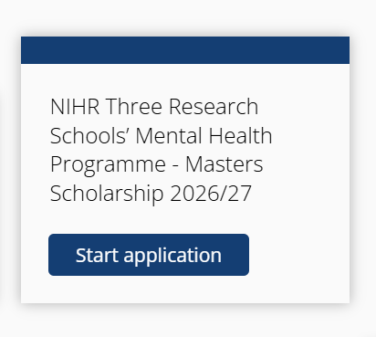
Once you have started an application it will be listed at the bottom of the page with its status and the option to download a PDF of your answers.

The application

If you have not already, please use these links to visit the SPCR website and read the important information on the master’s programme. There is some important guidance as well as information on who is eligible to apply for the programme.
It is important that you are familiar with all of this information before you start your application.

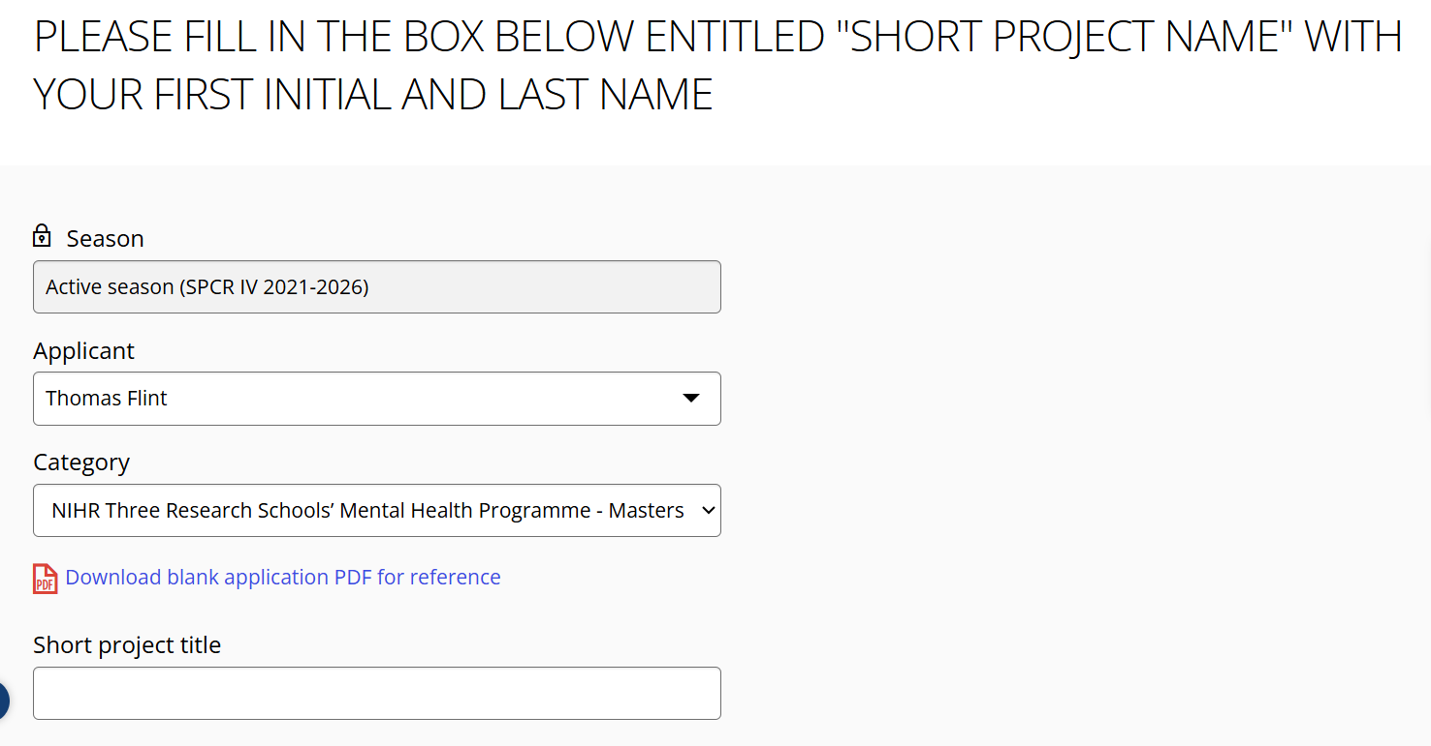

The box called ‘Short project title’ will be the name of your application. Please be sure to call it your first initial and last name e.g J Smith.

Before you can complete the main application questions you are required to answer two eligibility questions.
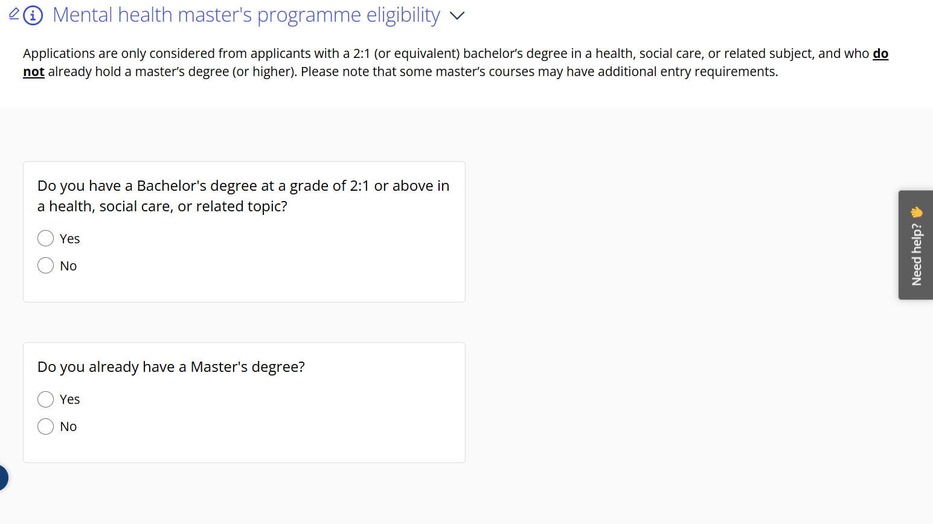
Please read the questions carefully as if you answer incorrectly the system will close your application and you will have to begin again.


You can navigate between pages using the tabs at the top or the save+next button at the bottom of each page. (The main application tabs will only be accessible once you have completed the eligibility questions).



Each section has guidance and important information displayed next to the answer box and where necessary the boxes are labelled as optional or word counts given.

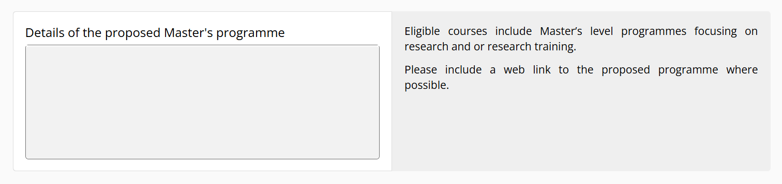
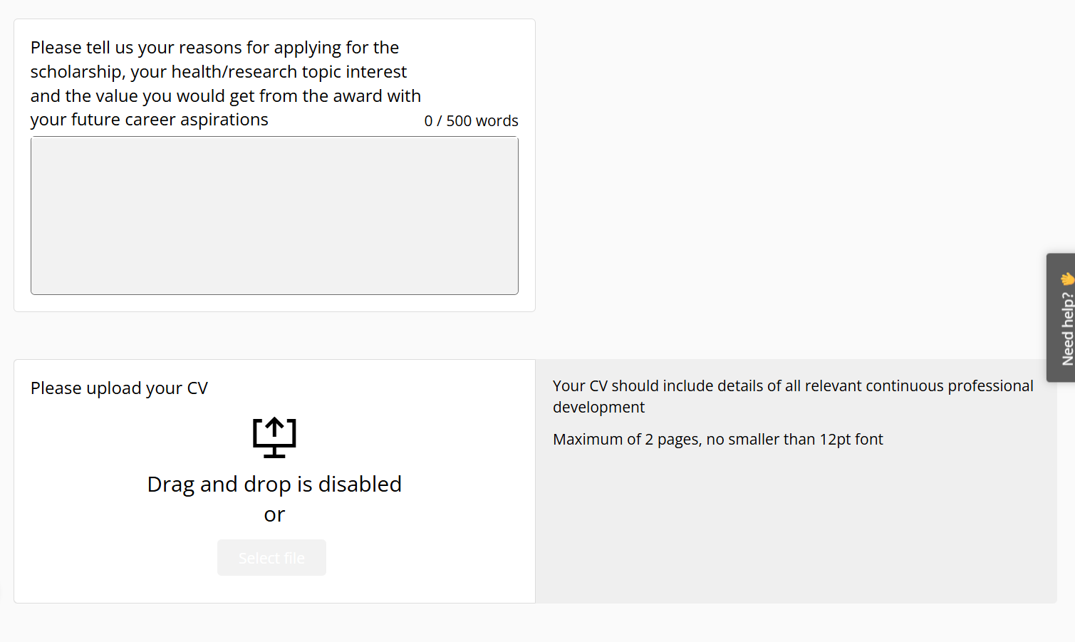

Once you have completed all sections, please take the time to review before submitting.
Even if you have submitted your application, you can still update or make changes until the deadline. After that, you cannot change your application or request changes to be made by SPCR.

If you have questions not answered by this guide or the help section on GoodGrants please contact us at spcr@keele.ac.uk
We do experience a high number of enquiries so please allow 3 working days for a reply.

