Improving mental health and wellbeing in underserved populations through collaborative research

Individual Research Career Development Award 2021

As part of the Three NIHR Research Schools Mental Health Programme we are inviting applications for Individual Research Career Development Awards. These are available to individuals already working in primary care, public health or social care in research, education or practice or people with research expertise in an aligned sector, topic area or discipline who wish to bring their skills and experience to primary care, public health or social care. We are keen to support professionals working in practice who wish to develop their research capacity, as well as individuals who are already in research careers.
We are seeking high-quality applications from individuals who have a commitment to developing the evidence base to improve mental health and wellbeing in underserved populations. Applicants can request funding of up to £25,000.
For this call, we would particularly welcome applications looking at conditions in the following Health Research Classification System (HRCS) ‘mental health’ categories:

Depression
Addiction
Anxiety
Learning disabilities

Commissioning process
All applications will be initially assessed to ensure that they are within the remit of this call, meet required criteria and that the form has been fully completed. Applications successfully passing this triage will be assessed by members of the schools who have a role in career development and capacity building and will be reviewed by the Three NIHR Research Schools Steering Group.

Selection criteria
Applications will be reviewed using the following criteria:
- Strong individual applicant
- Clear alignment with the remit of the Three NIHR Research Schools Mental Health Programme
- A strong case for personal development through this award
- A proposal clearly in line with the applicant’s current career stage
- Clear training/development plan that is integral to the award
- Clear endpoint and objectives for the research career development award
- A long-term commitment to a research career
- Value for money
- Level of collaboration across the Three NIHR Research Schools
Funding
Costs for the applicant’s salary, training (formal or short) courses and events, direct costs linked to the proposal are eligible. Supervision costs are ineligible.
It is for the applicant and relevant host organisation to determine whether to apply overheads. NIHR schools will only fund up to 30% of staff costs as overheads. These will be included as part of the budget requested. Funding will be paid to the host organisation. A contract for successful awards will be issued to the main host institution for the award based on standard NIHR SPCR terms. Awards may start from 1 April 2022 onwards.

Awards can be of any duration but must not extend beyond 31 March 2024

Applications should be emailed to e.g.fletcher@keele.ac.uk by 16 December 2021.

Applicants will be informed of the outcome by the end of January 2022.

Application Form

Applicant’s details
Surname
Forename
Title
Contact email
Contact address
Current post(s) held
Current organisation

PART 1: SUMMARY

Application title
Provide a summary of your application
[200 words maximum]

PART 2: APPLICANT’S BACKGROUND

Please describe:
- your career to date, including relevant experience for this proposed award, any relevant publications or other evidence of your research activities to date
- your career development goals
- your education and training to date.
[1,000 words maximum]
Please confirm whether you are currently registered for or undertaking a research doctorate (PhD/MD/DPhil) and specify type of registration and title of the thesis (include the date of registration and expected completion date and progress to date)

PART 3: CASE FOR SUPPORT

Please describe:
- background and rationale for your proposal
- aims and objectives
- plan of work
- any associated ethical considerations
- how this award fits with your career plan
- your training plan
- expected outcomes and markers of success
- plans for the involvement of public contributors/experts by experience.
[3,000 words maximum]

Please explain how your proposal fits with the NIHR Schools Mental Health Programme (detailed in Appendix One)
[1000 words maximum]
Please explain how your proposal meets the criteria of NIHR Schools Mental Health Programme (detailed in Appendix One)
[1000 words maximum]

PART 4: Gantt chart
Please submit a detailed Gantt chart with your application.

PART 5: RESOURCES

Resources requested for this award with detailed justification
Start date |  | End Date
Salary costs* |  | £
FTE
Overheads (30% of salary costs) |  | £
Non-staff costs |  | £
Total |  | £
Please provide a detailed justification of the resources requested

* Basic salary plus employer’s contribution to NI and superannuation

Please email this form and your Gantt chart to e.g.fletcher@keele.ac.uk by 16 December 2021 stating ‘Three Schools Career Development Award Application’ in the subject line.

If you have any questions, please email Dr Georgina Fletcher, Assistant Director, School for Primary Care Research e.g.fletcher@keele.ac.uk

Appendix One

Background

Improving mental health and wellbeing in underserved populations through collaborative research: NIHR Schools for Primary Care, Public Health and Social Care
The NIHR Schools for Primary Care Research (SPCR), Public Health Research (SPHR) and Social Care Research (SSCR) (“three Schools”) have joined together in a unique collaboration between leading academic centres in England to collaborate on two programmes of work funded through the National Institute for Health Research (NIHR): one on mental health led by SPCR and the second on dementia led by SSCR.
At least one in four people experience mental health problems, many of whom never access care and treatment. There are also large numbers of people with learning disability (prevalence c.2%) and autism (prevalence c.1%). Mental health problems, learning disabilities and autism generate challenges for individuals with these conditions, their families and the wider society, with often quite high utilisation of health, social care and other services. Those challenges are seen across the life course. The impacts of mental health problems on individuals and the wider societal and economic consequences are multiple and vast and include above-average rates of concurrent physical illnesses, shortened life expectancy, social exclusion, socioeconomic disadvantage, and the need for health and welfare support. Despite the high prevalence, many people do not receive the support they need and there are significant inequalities in access. These underserved groups include, but are not limited to, people with learning disabilities, parts of the autistic and neurodiverse community, people from Black and other ethnic minority backgrounds. There are also other geographical, demographic and socioeconomic inequalities which this proposal will address. Our proposal will address some of the most fundamental gaps in the evidence base. By working collaboratively across primary care, public health and social care, we will address problems in a multi-professional, multi-disciplinary way and at the individual, family, group and population levels using a variety of methodological approaches. Research will be underpinned by strong and diverse public, carer, service user and patient involvement and engagement. Our research will prioritise those groups with high needs for treatment and support, and that have been underserved by research to date. We will use NIHR ‘heatmaps’ (see appendix 1) to help us identify and address the disparity between need and research activity. (We recognise, however, that those ‘heatmaps’ have some limitations, including that they relate only to common mental disorders and do not cover severe mental illness, learning disability or autism, which are the conditions most likely to bring people into contact with social care services; nor do they cover child and adolescent mental illness.)
The NIHR Schools for Primary Care, Public Health and Social Care are uniquely placed to deliver this ambitious programme. We have strengths in mental health, learning disability and autism research and are committed to working more closely together to generate high-quality evidence that improves the health and wellbeing of the population in underserved areas. By working together, we can take a more holistic view of mental health, avoiding traditional ‘siloed’ research and generating the evidence needed by individuals, families, practitioners, and policy makers. We will draw on our expertise and established networks to ensure patient, carer, service user, public and community engagement and work across traditional disciplinary and sector boundaries.

All Schools have a strong portfolio of mental health research (e.g. https://www.sscr.nihr.ac.uk/projects/p137/, https://www.spcr.nihr.ac.uk/projects https://sphr.nihr.ac.uk/category/research/public-mental-health/) which this programme will build on and expand. There is also a strong record of research on learning disability and autism in the School for Social Care Research and a desire to develop work in these areas in the Schools for Public Health and Primary Care. We have an established infrastructure to operationalise these plans and have a strong track record in delivering high-quality commissioned research. This network will be unique to, but also complement, existing mental health and other relevant research networks and the NIHR Mental Health Policy Research Unit in its interdisciplinary focus across primary care-social care-public health.

Research Programme Criteria

- The programme supports proposals addressing a range of mental health conditions within the Health Research Classification System (HRCS) ‘mental health’ category, which includes depression, schizophrenia, psychosis and personality disorders, addiction, suicide, anxiety, eating disorders, learning disabilities, bipolar disorder, autistic spectrum disorders and studies of normal psychology, cognitive function and behaviour.

It will also support proposals with a focus on the wider determinants and prevention of poor mental health, and reduction of mental health inequalities and subsequent outcomes.

- Proposals must meet the needs of local populations within the context of national policy priorities. Research can cover any of the HRCS conditions and will be informed, but not limited, by priorities identified by the Mental Health Research Goals 2020-2030.

More details on each goal’s scope and example areas that the research may address are available on the Academy of Medical Sciences website.

NIHR’s themed call on learning disability research also informs our programme (https://content.nihr.ac.uk/nihrdc/themedreview-04326-BCAHFA/Better-Health_Care-For-FINALWEB.pdf).

- The host organisation should usually be based in an area identified by the NIHR ‘heat map’ as being underserved, however applications with the host outside these areas will be considered as long as there are strong connections to an underserved region

- Participant recruitment to any study must take place from the underserved region although this can be in conjunction with sites located in other regions, where the burden or need is high. The choice of recruitment regions and sub-localities must be justified in relation to the size of the impacts.

- Applicants are encouraged to use a mapping tool, such as the Research Targeting Tool, to demonstrate how the planned target population fit with prevalence and impacts. Special consideration should be given to the inclusion of people from socioeconomically disadvantaged groups and other underserved communities that are more affected by mental health problems. Research methods may involve primary research or evidence synthesis, including systematic reviews, intervention development and testing, modelling studies, or the analysis of existing datasets.

Appendix Two

Analysis of Regional Mental Health Burden and Research Activity

Extracted from NIHR webpage
https://www.nihr.ac.uk/documents/research-for-social-care-research-specification-for-mental-health-research-in-northern-england-call/28219#Analysis_of_Regional_Mental_Health_Burden_and_Research_Activity
There is a mismatch between regional research activities (measured by patient recruitment per 100,000 patients) in mental health and the prevalence of mental health conditions in England in the past 10 years (2010-19). The recruitment per 100,000 prevalence map shows where the highest proportion of people with mental health conditions are being recruited to research studies (figure 1).
The areas of highest prevalence per 1,000 map shows where mental health conditions are most prevalent, with the shade becoming paler as prevalence drops (figure 2).
Where are the highest proportions of people with common mental health conditions being recruited into mental health studies?
Figure 1: Recruitment per 1,000 prevalence 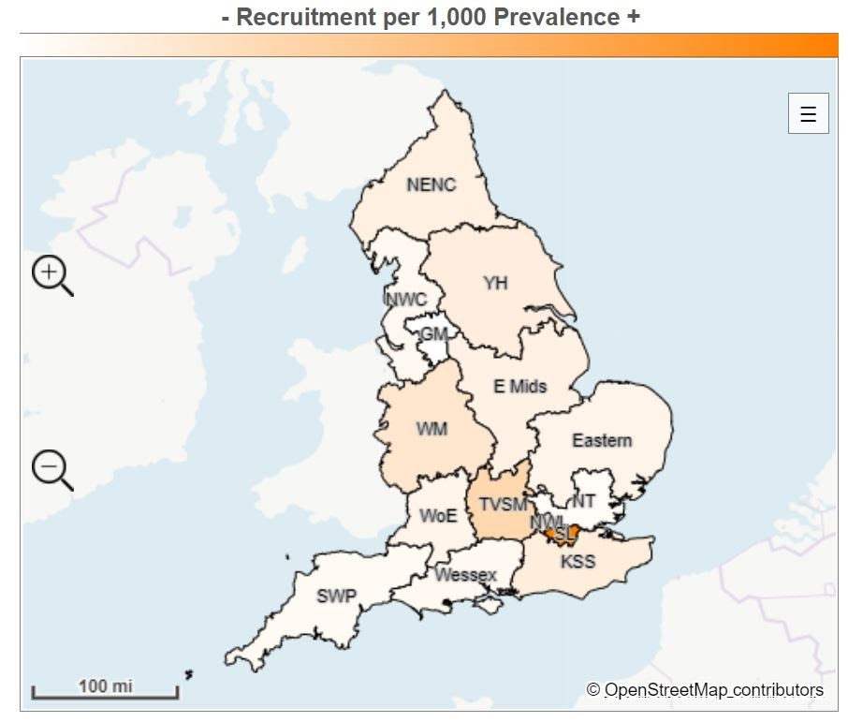
Local Clinical Research Network region | Recruitment | Prevalence | Recruitment per 100,000 prevalence
South London | 22,101 | 387,025 | 57.1
Thames Valley and South Midlands | 4,332 | 222,443 | 19.5
West Midlands | 7,484 | 568,463 | 13.2
North West London | 2,869 | 250,377 | 11.5
Kent, Surrey and Sussex | 4,286 | 426,269 | 10.1
Yorkshire and Humber | 6,145 | 630,356 | 9.7
North East and North Cumbria | 3,427 | 383,540 | 8.9
East Midlands | 3,442 | 420,127 | 8.2
Eastern | 3,108 | 418,186 | 7.4
West of England | 1,888 | 256,886 | 7.1
North West Coast | 2,929 | 521,317 | 5.6
Wessex | 1,559 | 289,753 | 5.4
South West Peninsula | 1,251 | 250,971 | 5.0
North Thames | 2,803 | 648,839 | 4.3
Greater Manchester | 1,133 | 430,692 | 2.6
England total | 68,757 | 6,114,244 | 11.2

Where are common mental health conditions most prevalent?
Figure 2: Weighted prevalence (per 1,000) +
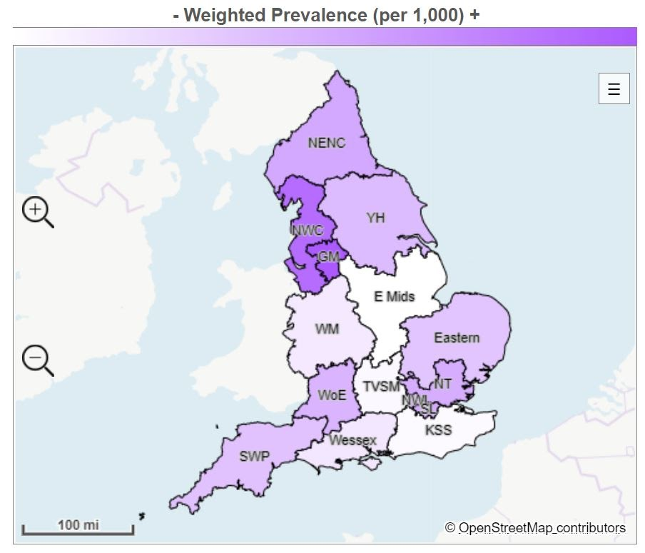
Local Clinical Research Network region | Prevalence | Adult population | Weighted prevalence (per 1,000)
Greater Manchester | 430,692 | 2,146,470 | 200.7
North West Coast | 521,317 | 2,707,490 | 192.5
North East and North Cumbria | 383,540 | 2,296,045 | 167.0
North West London | 250,377 | 1,505,994 | 166.3
South London | 387,025 | 2,328,617 | 166.2
North Thames | 648,839 | 3,952,295 | 164.2
West of England | 265,886 | 1,644,509 | 161.7
Yorkshire and Humber | 630,356 | 3,971,913 | 158.7
South West Peninsula | 250,971 | 1,611,110 | 155.8
Eastern | 418,186 | 2,704,008 | 154.7
Wessex | 289,753 | 2,065,847 | 140.3
West Midlands | 568,463 | 4,088,391 | 139.0
Thames Valley and South Midlands | 222,443 | 1,637,712 | 132.9
Kent, Surrey and Sussex | 426,269 | 3,218,657 | 132.4
East Midlands | 420,127 | 3,236,427 | 129.8
England total | 6,114,244 | 39,151,485 | 156.2

