Improving mental health and wellbeing in underserved populations through collaborative research

Research Award 2021

The NIHR Schools for Primary Care Research (SPCR), Public Health Research (SPHR) and Social Care Research (SSCR) (“three Schools”) have joined together in a unique collaboration between leading academic centres in England to collaborate on two programmes of work funded through the National Institute for Health Research (NIHR): one on mental health led by SPCR and the second on dementia led by SSCR.
At least one in four people experience mental health problems, many of whom never access care and treatment. There are also large numbers of people with learning disability (prevalence c.2%) and autism (prevalence c.1%). Mental health problems, learning disabilities and autism generate challenges for individuals with these conditions, their families and the wider society, with often quite high utilisation of health, social care and other services. Those challenges are seen across the life course. The impacts of mental health problems on individuals and the wider societal and economic consequences are multiple and vast and include above-average rates of concurrent physical illnesses, shortened life expectancy, social exclusion, socioeconomic disadvantage, and the need for health and welfare support. Despite the high prevalence, many people do not receive the support they need and there are significant inequalities in access. These underserved groups include, but are not limited to, people with learning disabilities, parts of the autistic and neurodiverse community, people from Black and other ethnic minority backgrounds.
As part of the Three NIHR Research Schools Mental Health Programme we are inviting applications for research projects that will prioritise those groups with high needs for treatment and support, and that have been underserved by research to date to address some of the most fundamental gaps in the evidence base. By working collaboratively across primary care, public health and social care, we will address problems in a multi-professional, multi-disciplinary way and at the individual, family, group and population levels using a variety of methodological approaches.
This programme seeks to address some of the most fundamental gaps in the evidence base. By working collaboratively across primary care, public health and social care, we will address problems in a multi-professional, multi-disciplinary way and at the individual, family, group and population levels using a variety of methodological approaches.
Research proposals submitted to this call should be underpinned by strong and diverse public, carer, service user and patient involvement and engagement. The programme will prioritise research with groups with high needs for treatment and support, and that have been underserved by research to date. NIHR ‘heatmaps’ (see appendix 1) should be used to help identify and address the disparity between need and research activity. We recognise, however, that those ‘heatmaps’ have some limitations, including that they relate only to common mental disorders and do not cover severe mental illness, learning disability or autism, which are the conditions most likely to bring people into contact with social care services; nor do they cover child and adolescent mental illness.

For this call, we would particularly welcome applications looking at conditions in the following Health Research Classification System (HRCS) ‘mental health’ categories:

Depression
Addiction
Anxiety
Learning disabilities

Commissioning process

All applications will be assessed by the Three NIHR Research Schools Steering Group to ensure three appropriate coverage of relevant themes and geography. Applications will be sent for review outside the schools.

Applicants will be informed of the outcome by the end of January 2022.

Selection criteria
Applications will be reviewed using the following criteria:

- Relevance and importance to the priorities and needs of primary care, public health and social care
- Clear alignment with the remit of the Three NIHR Research Schools Mental Health Programme
- Awareness and understanding of previous relevant research or developments in this area
- Appropriateness of the research design in relation to the stated objectives
- Appropriateness of the work plan and project management arrangements
- Strength of the dissemination plan
- Strength of the proposed plans for patient and public involvement throughout the duration of the research
- Level of collaboration across the Three NIHR Research Schools

Funding
There is £500k available for this call.
Awards may start from 1 April 2022 onwards.
Awards can be of any duration but must not extend beyond 31 March 2024

Applications should be emailed to e.g.fletcher@keele.ac.uk by 16 December 2021.

For office use:

HRCS mental health category
Geographical location
SSCR/SPCR/SPHR

Section A: Applicants' details

A1; Principal Investigator name:
A2; PI ORCID number http://orcid.org/:

A3: PI based in (School):
Choose an item.
A1a; Co-PI name (if applicable)

A2a; Co-PI ORCID number

A3a; Co-PI based in
Choose an item.
A4: Details of co-applicants. Include name, email, job title, professional background and ORCID as a minimum.
A5: Details of public co-applicant or collaborator (no ORCID or email address is required):

A6: Summary of team expertise:

A7: Please describe the value of the collaboration across the schools in this project: (no more than 450 words)

Section B: Project details

B1; Project title:

B2; Project short name:

B3; Plain English Summary: http://www.invo.org.uk/resource-centre/plain-english-summaries/ (no more than 450 words)

B4; Expert Summary: (no more than 450 words)

B5; Five key words to describe the project:

B6; Project start date
Click or tap to enter a date.
B7; Project end date
Click or tap to enter a date.
B8; Duration (months);

B9: How does this project fit with the Three NIHR Schools Mental Health Research brief? (no more than 450 words)

B10; Proposed project protocol. This should be no more than 6 pages. If you are providing a reference list, this should be included in the 6 pages.

B11; Describe the involvement of patients/public/practitioners/people with lived experience/carers in developing this application:

B12; How will patients/public/practitioners/people with lived experience/carers be involved in your research? Please describe who (i.e. particular demographics, how many, what relationships will be created etc.) you would like to involve, why them and at which stages of your research you are expecting to involve them:

B13; Total funding requested with brief justification of funds requested: (Please do not repeat the information that you have included in the costing spreadsheet.)

B14; Will the project help build capacity and offer development opportunities? e.g. ECR as co-app

B15; Will this project link to other parts of the NIHR, e.g. ARC? If yes, please describe.

B16; Will this project be eligible for adoption to the NIHR CRN portfolio?

B17; What is the planned dissemination strategy throughout this project: (we appreciate that this will evolve over time)

B18; What are the likely impacts on policy and/or practice from this project: (we appreciate that these will evolve over time) https://www.nihr.ac.uk/researchers/apply-for-funding/how-to-apply-for-project-funding/plan-for-impact.htm

B19; Any other information you wish to include:

B20; Please provide the names and email addresses of up to 3 people we can contact for external review of this project (these should not be based within your school’s membership)

Please email this form, the costing spreadsheet and your Gantt to e.g.fletcher@keele.ac.uk by 16 December 2021 stating ‘Three Schools Research Award Application’ in the subject line.

If you have any questions, please email Dr Georgina Fletcher, Assistant Director, School for Primary Care Research e.g.fletcher@keele.ac.uk
Background

Improving mental health and wellbeing in underserved populations through collaborative research: NIHR Schools for Primary Care, Public Health and Social Care
The NIHR Schools for Primary Care Research (SPCR), Public Health Research (SPHR) and Social Care Research (SSCR) (“three Schools”) have joined together in a unique collaboration between leading academic centres in England to collaborate on two programmes of work funded through the National Institute for Health Research (NIHR): one on mental health led by SPCR and the second on dementia led by SSCR.
At least one in four people experience mental health problems, many of whom never access care and treatment. There are also large numbers of people with learning disability (prevalence c.2%) and autism (prevalence c.1%). Mental health problems, learning disabilities and autism generate challenges for individuals with these conditions, their families and the wider society, with often quite high utilisation of health, social care and other services. Those challenges are seen across the life course. The impacts of mental health problems on individuals and the wider societal and economic consequences are multiple and vast and include above-average rates of concurrent physical illnesses, shortened life expectancy, social exclusion, socioeconomic disadvantage, and the need for health and welfare support. Despite the high prevalence, many people do not receive the support they need and there are significant inequalities in access. These underserved groups include, but are not limited to, people with learning disabilities, parts of the autistic and neurodiverse community, people from Black and other ethnic minority backgrounds. There are also other geographical, demographic and socioeconomic inequalities which this proposal will address. Our proposal will address some of the most fundamental gaps in the evidence base. By working collaboratively across primary care, public health and social care, we will address problems in a multi-professional, multi-disciplinary way and at the individual, family, group and population levels using a variety of methodological approaches. Research will be underpinned by strong and diverse public, carer, service user and patient involvement and engagement. Our research will prioritise those groups with high needs for treatment and support, and that have been underserved by research to date. We will use NIHR ‘heatmaps’ (see appendix 1) to help us identify and address the disparity between need and research activity. (We recognise, however, that those ‘heatmaps’ have some limitations, including that they relate only to common mental disorders and do not cover severe mental illness, learning disability or autism, which are the conditions most likely to bring people into contact with social care services; nor do they cover child and adolescent mental illness.)
The NIHR Schools for Primary Care, Public Health and Social Care are uniquely placed to deliver this ambitious programme. We have strengths in mental health, learning disability and autism research and are committed to working more closely together to generate high-quality evidence that improves the health and wellbeing of the population in underserved areas. By working together, we can take a more holistic view of mental health, avoiding traditional ‘siloed’ research and generating the evidence needed by individuals, families, practitioners and policy makers. We will draw on our expertise and established networks to ensure patient, carer, service user, public and community engagement and work across traditional disciplinary and sector boundaries.

All Schools have a strong portfolio of mental health research (e.g. https://www.sscr.nihr.ac.uk/projects/p137/, https://www.spcr.nihr.ac.uk/projects https://sphr.nihr.ac.uk/category/research/public-mental-health/) which this proposal will build on and expand. There is also a strong record of research on learning disability and autism in the School for Social Care Research and a desire to develop work in these areas in the Schools for Public Health and Primary Care. We have an established infrastructure to operationalise these plans and have a strong track record in delivering high-quality commissioned research. This network will be unique to, but also complement, existing mental health and other relevant research networks and the NIHR Mental Health Policy Research Unit in its interdisciplinary focus across primary care-social care-public health.

Research Programme

This research initiative will support proposals addressing a range of mental health conditions within the Health Research Classification System (HRCS) ‘mental health’ category, which includes: depression, schizophrenia, psychosis and personality disorders, addiction, suicide, anxiety, eating disorders, learning disabilities, bipolar disorder, autistic spectrum disorders and studies of normal psychology, cognitive function and behaviour. It will also include a focus on the wider determinants and prevention of poor mental health, and reduction of mental health inequalities and subsequent outcomes.

The proposed research programme has several complementary strands, for example commissioned studies, practitioner-led initiatives and co-created research that meets the needs of local populations within the context of national policy priorities. Research can cover any of the HRCS conditions and will be informed, but not limited, by priorities identified by the Mental Health Research Goals 2020-2030. More details on each goal’s scope and example areas that the research may address are available on the Academy of Medical Sciences website. NIHR’s themed call on learning disability research will also inform our programme (https://content.nihr.ac.uk/nihrdc/themedreview-04326-BCAHFA/Better-Health_Care-For-FINALWEB.pdf).

The host organisation must be based in areas identified by the NIHR ‘heat map’ as being underserved, however collaborators outside of these areas are welcome. Participant recruitment to the study must take place from the underserved region although this can be in conjunction with sites located in other regions, where the burden or need is high. The choice of recruitment regions and sub-localities must be justified in relation to the size of the impacts. As with the recent NIHR Research for Patient Benefit Mental Health Research in Northern England call, we encourage applicants to use a mapping tool, such as the Research Targeting Tool, to demonstrate how the planned target population fit with prevalence and impacts. Special consideration should be given to the inclusion of people from socioeconomically disadvantaged groups and other underserved communities that are more affected by mental health problems. Research methods may involve primary research or evidence synthesis, including systematic reviews, intervention development and testing, modelling studies, or the analysis of existing datasets.

Co-created research (Years 2-3)

To support underserved communities, we need to better understand their needs, which are likely to be complex and span traditional health and care boundaries. This will allow us to co-create research that has a greater impact on local populations. We will establish a series of workshops, attended by academics, practitioners, users, carers and patients or other experts by experience from the NIHR Schools for Primary Care, Public Health and Social Care Research to identify, prioritise and design mental health research meeting the needs of underserved areas.

Workshops will be open to the broadest range of stakeholders (including non-School academic departments), providing additional networking and collaborative opportunities. Workshop findings will be published as outputs in their own right. We will work with our involvement team to ensure strong user and practice representation at the workshops. This will include people with lived experience, their families and carers, local authority, NHS, third sector, private sector, housing services, and education partners.

Workshops will prioritise topics for funding in years 2 and 3 of this proposal. When developed by the workshop team, studies will be externally peer-reviewed. Our steering committee will review the range of proposals to ensure appropriate coverage of relevant themes and geography.

Appendix One

Analysis of Regional Mental Health Burden and Research Activity

Extracted from NIHR webpage
https://www.nihr.ac.uk/documents/research-for-social-care-research-specification-for-mental-health-research-in-northern-england-call/28219#Analysis_of_Regional_Mental_Health_Burden_and_Research_Activity
There is a mismatch between regional research activities (measured by patient recruitment per 100,000 patients) in mental health and the prevalence of mental health conditions in England in the past 10 years (2010-19). The recruitment per 100,000 prevalence map shows where the highest proportion of people with mental health conditions are being recruited to research studies (figure 1).
The areas of highest prevalence per 1,000 map shows where mental health conditions are most prevalent, with the shade becoming paler as prevalence drops (figure 2).
Where are the highest proportions of people with common mental health conditions being recruited into mental health studies?
Figure 1: Recruitment per 1,000 prevalence 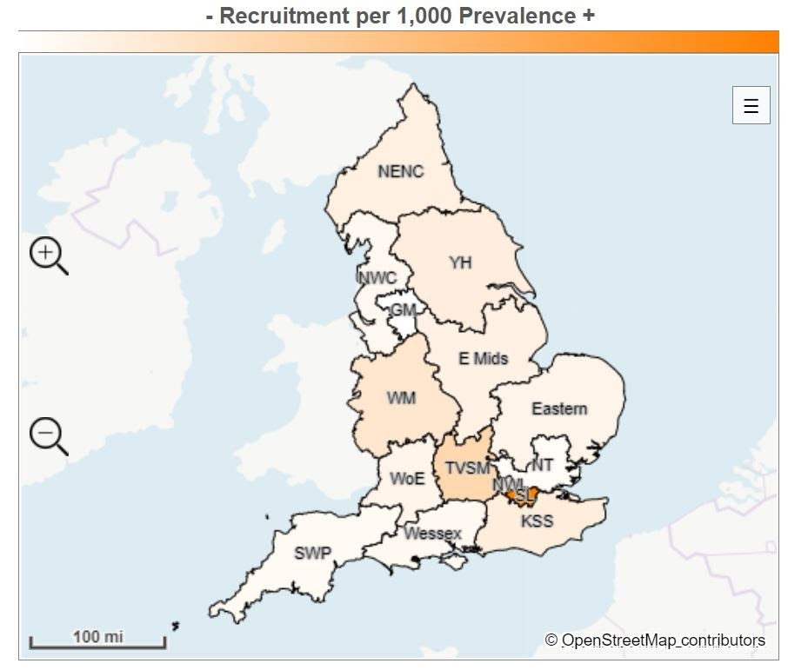
Local Clinical Research Network region | Recruitment | Prevalence | Recruitment per 100,000 prevalence
South London | 22,101 | 387,025 | 57.1
Thames Valley and South Midlands | 4,332 | 222,443 | 19.5
West Midlands | 7,484 | 568,463 | 13.2
North West London | 2,869 | 250,377 | 11.5
Kent, Surrey and Sussex | 4,286 | 426,269 | 10.1
Yorkshire and Humber | 6,145 | 630,356 | 9.7
North East and North Cumbria | 3,427 | 383,540 | 8.9
East Midlands | 3,442 | 420,127 | 8.2
Eastern | 3,108 | 418,186 | 7.4
West of England | 1,888 | 256,886 | 7.1
North West Coast | 2,929 | 521,317 | 5.6
Wessex | 1,559 | 289,753 | 5.4
South West Peninsula | 1,251 | 250,971 | 5.0
North Thames | 2,803 | 648,839 | 4.3
Greater Manchester | 1,133 | 430,692 | 2.6
England total | 68,757 | 6,114,244 | 11.2

Where are common mental health conditions most prevalent?
Figure 2: Weighted prevalence (per 1,000) +
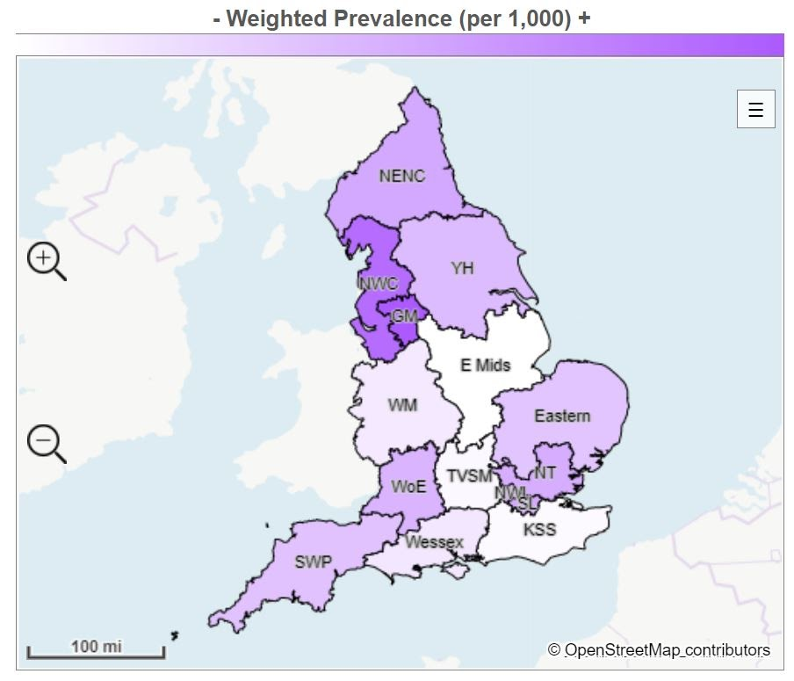
Local Clinical Research Network region | Prevalence | Adult population | Weighted prevalence (per 1,000)
Greater Manchester | 430,692 | 2,146,470 | 200.7
North West Coast | 521,317 | 2,707,490 | 192.5
North East and North Cumbria | 383,540 | 2,296,045 | 167.0
North West London | 250,377 | 1,505,994 | 166.3
South London | 387,025 | 2,328,617 | 166.2
North Thames | 648,839 | 3,952,295 | 164.2
West of England | 265,886 | 1,644,509 | 161.7
Yorkshire and Humber | 630,356 | 3,971,913 | 158.7
South West Peninsula | 250,971 | 1,611,110 | 155.8
Eastern | 418,186 | 2,704,008 | 154.7
Wessex | 289,753 | 2,065,847 | 140.3
West Midlands | 568,463 | 4,088,391 | 139.0
Thames Valley and South Midlands | 222,443 | 1,637,712 | 132.9
Kent, Surrey and Sussex | 426,269 | 3,218,657 | 132.4
East Midlands | 420,127 | 3,236,427 | 129.8
England total | 6,114,244 | 39,151,485 | 156.2

