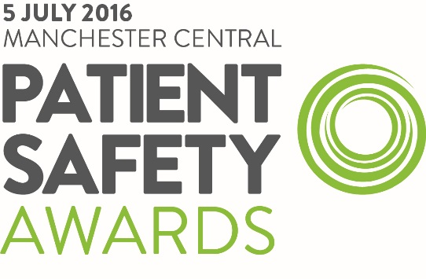

For Immediate Release: Wednesday 8 June 2016

We are delighted to announce that NIHR School for Primary Care Research has been shortlisted for the 2016 Patient Awards, in the category Improving Safety in Primary care to be held at Manchester Central on the 5 July, on the first day of the Patient Safety Congress.
An extraordinary high-standard of entries were submitted for this year’s awards, which demonstrates the continued commitment to improving patient safety. There were over 650 submissions, of which 170 made it to the final cut, which means that there is fierce competition for these coveted awards.
With increased pressure to deliver services with restricted budgets, it is even more important this year to recognise and reward outstanding practice within the NHS and independent healthcare organisations and to shine a spotlight on the achievements of not only the individuals and teams concerned, but organisations as a whole.
Alastair McLellan, Editor, HSJ and Jenni Middleton, Editor, Nursing Times:
“Congratulations to the finalists of the Patient Safety Awards 2016. This year the awards really highlight those organisations who are not only doing their day jobs, but going above and beyond every day to deliver exceptional patient care and safety. The projects submitted demonstrate those who are constantly innovating and overcoming challenges to put patients’ needs first.”
Winners will be announced on the evening of 5 July at Manchester Central, Manchester, where over 800 of the industry elite will join together for a night of recognition, rewarding and networking.
The full list of finalists can be viewed online here: https://www.patientsafetycongress.co.uk/2016-shortlist and downloaded in PDF format here: https://www.patientsafetycongress.co.uk/resources/patient-safety-awards-shortlist-2016

